
Course Outline (50 Hours)
Intro to Gaming (15 Classes)
History, Genres, Platforms and Vocabulary of Video Gaming
Ethics of Gaming
Is gaming good for society? – Facts/Debate/Discussion Greatest genre/console/platform Project and Presentation
Board Games - Examples and styles of board games
Careers in Gaming – is game-testing a career? Streaming?
Tips on Game Design – what do you need to know?
Game Design (35 Classes)
Design your own games using several game-making programs!


Course Assessment
Daily Quizzes/Assignments 30%
Projects/Presentation 60%
Attitude/Discussion 10%
http://upload.wikimedia.org/wikipedia/en/c/c4/EA_Sports_logo.png
http://supermario3dworld.nintendo.com/_ui/img/views/story/good-guys.png

Course Mentality
This class gives the student a tremendous opportunity; a chance to discuss and explore the world of gaming with classmates in a school setting. That being said, this requires a great deal of responsibility on the students’ part to respect the course, and the lessons that it entails. The student will be challenged to consider different forms of gaming, the positive and negative impacts gaming has, and utilize their creativity to conceptualize their game. In the past we have partnered with Saskatchewan Polytechnic - Palliser and they provide a workshop to create a game while students receive information about the business and information technology program and careers associated with it.

Outcomes
What you should be able to do at the conclusion of this course:
G9.1  G9.2  G9.3  G9.4  G9.5  G9.6 | I CAN state options to pursue a career in gaming.  I CAN become familiar with different game-designing programs and software.  I CAN challenge stigma associated with gaming while critiquing its influence.  I CAN state a basic history of video games and understand gaming-related vocabulary.  I CAN create an idea and plan for the creation of a new game.  I CAN experiment with game design software.

Course Expectations
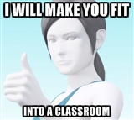
What I expect from you:
- Ask questions – use your phone (when allowed) to answer q’s/record homework
- Have a positive attitude and respect others in the class.
- Complete your assignments - keep up!
- Come to class prepared to learn.
- Maturity – this class is a great opportunity, don’t squander it!
What you can expect from me:
- Positive attitude, approachable, willing to help
- Feedback to help you grow
- I will try to be as fair as possible while challenging you!

Assessment
30% - Daily Quizzes/Minor Assignments
The world of gaming has a lot of content: the platforms (and their specs) that games belong to, the different genres, the history of gaming, the stories that games tell, connecting games to Science, Math and English; and the societal impact of gaming are all things we will discuss. In order to assess your understanding of this content, you will be asked to complete a quiz at the beginning of most classes to assess and reflect on your learning. During class, you may have assignments to become more engaged in your learning.
10% - Presentation(s)
This class has several large projects that will require a fair amount of class time to complete, it is important that you utilize this class time wisely when it is given. This should help build strong habits that extend beyond the Gaming 90 content and hopefully create connections to your other courses. It is a good opportunity to establish and understand high school expectations for presentations and projects.

10% - Attitude/Discussion
People have similar and differing views on games, so respect other opinions and provide yours. Discussion mark is based on talking in turn, contributing to discussion positively, and other expectations as determined by the class. This includes considerations of attendance and homework completion.
50% - Create a Game - Final Product
You will be required to complete a game by the end of the course using one of the platforms we learned about in class.

Daily Routine and Class Philosophy
This class will follow a pretty consistent routine of quizzes at the start of a class and a video with a discussion to end the class. There will be occasional classes that will be work periods to work on projects in class and this will differ from the typical routine. It will look similar to the following:
Routine
Quiz and Self-Assessment (correction) – 5 minutes
Presentation, demonstrations guided by instructor, group work (assignments may be during this) – 45 minutes
YouTube video regarding Gaming (ExtraCredit) – 8 minutes
Closing discussion, what stood out from the day – 5 minutes
OR
Dedicated game design time.
Phones
We will try to push for as digitally-involved classroom as we can, if your student has a phone (or a tablet) and headphones, I am encouraging them to bring them to class on a daily basis. This is meant to encourage responsible use of phones and technology in a school setting to allow students to pursue their learning beyond the walls of the school while critiquing credibility of information sources.
Deadlines and Assignment Submission
Deadlines will be important in this class but it is important to note that resubmission of assignments or rewriting of quizzes is encouraged. Advocating for your work will lend itself to improving learning in all classes. Written and/or oral feedback should accompany assignments and they should give you tips to improve your submissions; these tips will help you grow as a learner.

Personal Teaching Philosophy

- Everyone is capable of learning and leading in many different ways.
- We live in a world full of systemic inequities and need to address and accommodate for them.
- Objective, critical thinking needs to be approached in all avenues of life.
- Communication and collaboration promotes change. Be open to new ideas and opinions.
- Be aware of your privileges or disadvantages and determine a means to utilize or overcome them.
- Some opinions are not acceptable and infringe upon human rights, but they still need to be addressed with compassion if education is to occur.
- Everyone deserves the benefit of the doubt. I would rather believe someone is being genuine and compassionate and be wrong, than believe someone was insincere and be right.
- Respect nature and try to find an altruistic means of happiness.
- Personal health is important and requires balance through all dimensions of your health and well-being.
- Celebrating and valuing diversity builds relationships and strong communities.
- Most importantly: I love my job, life and my students and I feel extremely fortunate to contribute to their growth and learning.

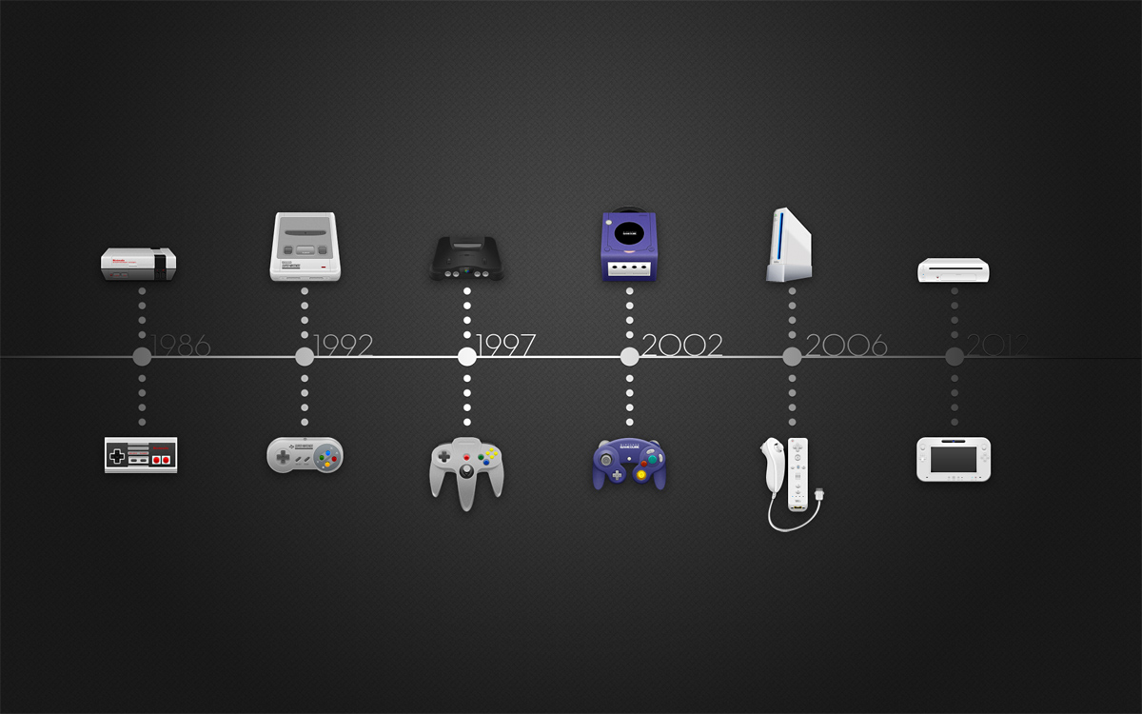
Source: http://rebloggy.com/post/gaming-nintendo-timeline-gameboy-console-max-steenbergen/31872090012

Contact Information
Mr. Logan Petlak
Email: petlak.logan@prairiesouth.ca
Room: 306
Website: loganpetlak.ca
Twitter: @mrlpetlak
CCI Phone Number: 306-693-4691
Please read through the course outline with your parent/guardian. Have your parent/guardian sign a copy of this course outline and return it to class, including their e-mail. I would like to have it so that they may contact me at their convenience or so that I may contact them regarding questions about our learning. Parent/Guardians may also get a look at what we learn about on the website.
Dear Parent/Guardian,
I understand that there may be some reservations and questions regarding this course’s content. This outline lists a large portion of the expectations and our progress throughout the course. I believe that it is important for your student to understand the unique opportunity a class like this can provide for learning, and it is intended to challenge them to become more responsible gamers, gain experience with information technology, and provide possible career considerations. I appreciate your feedback and welcome questions regarding the content that you may have (my information is listed above). I look forward to working with your child and all students in this class! We will be taking a trip to work with Saskatchewan Polytechnic during this course, so expect further information to be sent home in the near future.
Thank you,
Logan Petlak
______________________________________________________________________
Parent/Guardian's Name and E-mail: Parent/Guardian's Signature:
____________________________ _________________________
____________________________

Student's E-mail: Student's Signature:
____________________________ __________________________
Date:
________________________________

