Environment and Climate Change
National Emissions Inventory
Air Pollution Web quest

Introduction
The quality of air can vary widely depending where you live. While nearly any area will experience some level of air pollution, the types and amounts of each can change depending on what is nearby. This web quest will help you identify some of the major point sources of pollution in your area.

Background
The Clean Air Act, originally passed in 1963 then amended in 1970 and 1990, established acceptable air quality levels for criteria pollutants. For each pollutant listed, identify the chemical formula (if applicable) and describe its physical properties.

Pollutant | Chemical Symbol | Physical Characteristics | Health Effects
Sulfur dioxide | SO₂ | Colorless, foul-smelling gas that is produced by burning fossil fuels. | Increased risk of respiratory disease. Worsens asthma.
Carbon monoxide
Nitrogen oxides
Ozone
Particulate Matter
Lead

Accessing Local Facility Data
- Visit the 2014 Interactive Indicators Database at http://maps-cartes.ec.gc.ca/indicators-indicateurs/?lang=en
- At the top of the map, select the proper “Theme” (air) and “Indicators” for each table below – So for example: select “Air pollutant emissions: carbon monoxide” “update map”
- Zoom in towards Saskatchewan on the map
- Explore each of the industries and rank them in order from greatest emitter to least. (Top 5). Click on the dot, then select the industry you’d like to explore. Hint – This info is ranked for you in a table at the bottom of the page.
- Zero in on Moose Jaw/Regina and identify the greatest offenders in our region.
In the tables below, list the top five emissions facilities in your Province for each air pollutant. Give the amount of emissions in tons and its N. American Industry Classification System (NAICS) description. Use the given street address to mark the location of the top three facilities for each pollutant on your map on the last page.
Sulfur oxides (SO₂)
Site Name and Location | Annual Emissions  (in tons) | NAICS Description

Carbon Monoxide (CO)
Site Name and Location | Annual Emissions  (in tons) | NAICS Description

Volatile Organic Compounds (VOC)
Site Name and Location | Annual Emissions  (in tons) | NAICS Description

Total Particulate Matter
Site Name and Location | Annual Emissions  (in tons) | NAICS Description

Moose Jaw/Regina Offenders – Greenhouse Gasses
Site Name and Location | Annual Emissions  (in tons) | NAICS Description
Pollution Map
Go to the live wind map at https://www.windfinder.com and search the current wind currents in your city. Take a pencil and lightly draw arrows showing the direction of these wind currents.

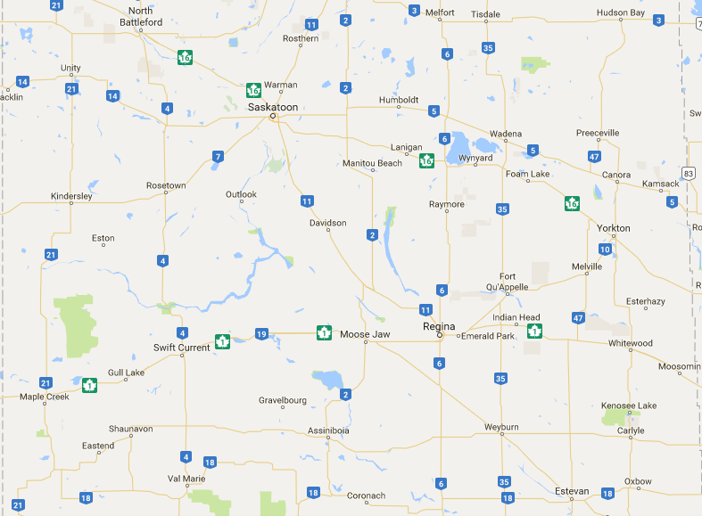

- Are the pollutants described in this activity primary or secondary pollutants? Explain the difference.

- What city or area in your province had the highest concentration of air pollution-emitting facilities? Why?

- Acid rain is produced when nitrogen oxides and sulfur dioxides react with water in the air. Given the wind patterns as currently shown on your map, what area(s) would possibly be affected by acid rain due to air pollution in the Province?

- Which Industries seemed to be the biggest offenders in Saskatchewan? Why do you think that is?

- Which province is the biggest producer of emissions? Why do you think that is?

