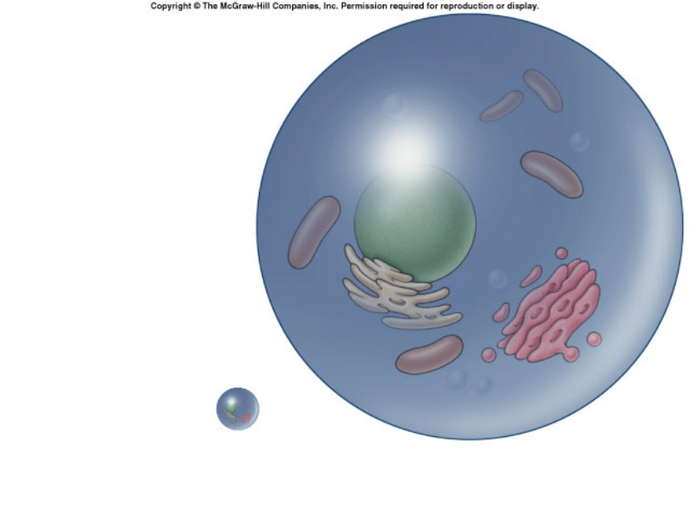
Surface Area to Volume Lab
Why Cell Size/Shape Matters
Most cells are between 2 micrometers and 200 micrometers—too small to be seen with the naked eye. Remember, a micrometer is 1 millionth of a meter! Why can’t cells ever become larger than that? We regularly find one-celled organisms the size of small multicellular animals, like frogs or even flies? In other words, why can’t there ever be an organism which is visible to the naked eye and that is one giant cell?
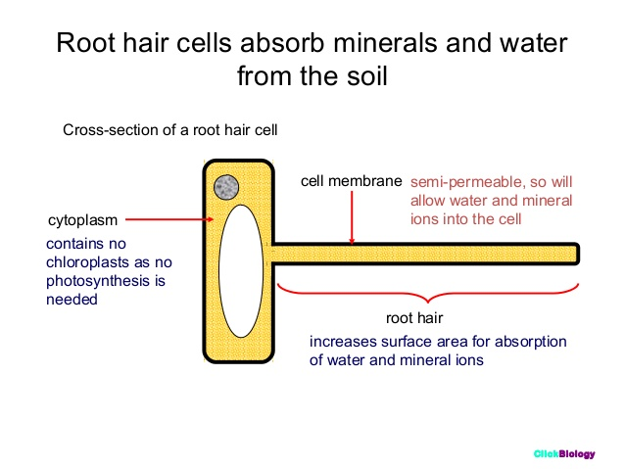
In order for cells to survive, they must constantly exchange ions, gases, nutrients, and wastes with their environment. These exchanges take place at the cell’s surface-across the cell membrane. The movement of these materials is accomplished mostly by diffusion (flow of solutes down a concentration gradient) across the cell membrane. Consequently, factors that can affect diffusion can affect the survival of a cell.

One of the core principles that govern the efficiency of diffusion is the ratio of surface area to volume. Surface area is the amount of cell membrane available for diffusion. So for a cell, surface area actually represents how much diffusion that can happen at one time. Whereas volume is the amount of cytoplasm contained within the cell membrane. So for a cell, volume is how long it takes to get from the membrane to the center of the cell by diffusion.

Therefore, to perform diffusion efficiently, there must be an adequate ratio between the cell’s surface area and its volume. But as a sphere (the simplest model of cell shape) gets larger, its volume increases at a different rate than its surface area. In this lab, we will investigate this relationship and how it affects diffusion time.

The prime limitation to cell size is the limitation imposed by diffusion. Diffusion is a very slow process. If a cell were 20 cm (~8 inches), it would take days for nutrients to reach its center or for wastes to reach the cell membrane. The cell would quickly starve to death or poison itself with its own wastes. So what’s the solution, if a cell approaches its maximum size? It’s time to divide! If cells receive the proper signals, they will divide by mitosis before they become too big.

PROCEDURE

In this lab activity, you will use agar cubes as cell models. You will investigate how increasing a cell’s size affects the time for diffusion to move material across the cell. The agar for the cubes has been dyed with bromothymol blue—a pH indicator. When the agar cubes are placed in an acidic solution, they will begin to turn yellow as the acidic solution diffuses into the agar. You will time this diffusion process for 3 different sized cells and compare them. Diffusion will be considered complete when the blue color completely disappears from the center of the cell.

- Using a dull knife or a thin strip of hard plastic, cut three blocks of agar of different sizes (sizes are listed in data table below). These three blocks will be your models for cells.
- Place model cells into a 400mL beaker and cover model cells with acidic solution. Begin timing.
- Periodically, gently stir the solution or turn the cubes over.
- Record the time for complete diffusion. This will be once the blue color completely disappears.

Table 1. Cell Dimensions and Time for Diffusion
Cell Size  (cm) | Surface Area | Volume | SA : V  ratio | Time for Complete Diffusion
1 x 1 x 1
2 x 2 x 2
1 x 1 x 8

1. As the cube increases in size, what happens to the surface area to volume ratio? Explain. (2)

2. Which cell had the fastest diffusion time? Explain why. (2)

3. The 2x2x2 cell and the 1x1x8 cell have the same volume. Were their diffusion times the same? Explain why or why not. (2)

4. In general, what is the relationship between the SA:V ratio and diffusion time? (1)

5. Explain why cells can’t get very, very big. (1)

6. Describe different ways that cell shape can be modified so that diffusion rate will be decreased to support life processes. (2)

7. Give an example of a type of cell in a living organism (animal or plant) that is shaped very differently than the classical round or boxy shape that you see drawn in introductory textbook chapters on cells. Explain how that unique shape is tied to the function that those cells perform. (2)

